ALLAMA IQBAL OPEN UNIVERSITY, ISLAMABAD
(Department of English Language & Applied Linguistics)

WARNING
- PLAGIARISM OR HIRING OF GHOST WRITER(S) FOR SOLVING THE ASSIGNMENT(S) WILL DEBAR THE STUDENT FROM AWARD OF DEGREE/CERTIFICATE, IF FOUND AT ANY STAGE.
- SUBMITTING ASSIGNMENTS BORROWED OR STOLEN FROM OTHER(S) AS ONE’S OWN WILL BE PENALIZED AS DEFINED IN “AIOU PLAGIARISM POLICY”.

Course: Compulsory English I Course Code: 207

Level: Matric / SSC Semester: Spring, 2011

Total Marks: 100 Pass Marks: 40
ASSIGNMENT No. 1
(Units 1–3)

Q.1 Make WH questions of the following sentences using the WH words given in the brackets. (10)

i. I’m Zain Ali. (Who)
ii. I’m twenty four years old. (How)
iii. I work in railway department. (Where)
iv. I work because I want to pay my University fees. (Why)
v. My job is to make bills. (What)

Q.2 A. You have to give the following information to apply for a post of a technician. Fill in the chart giving information about yourself. (10)

Full Name
Father’s Name
Date of Birth
Home Address
Telephone Numbers
Education
Occupation
Language/s spoken
Interests/hobbies

B. Now use the information that you have given above and write a paragraph about yourself. (10)

Q.3 A. Read the two examples and then write the jobs / professions of the people. (10)

Examples:
- People who drive our motorcars are drivers or chauffeurs.
- People who make law for us are lawmakers or legislators.

i. People who keep our streets and drains clean are ______________.
ii. People who sell us vegetables are ______________.
iii. People who stitch our clothes are ___________.
iv. People who mend shoes are _______________.
v. People who deal in and prescribe eye glasses are__________.

B. What do the following people do? Read the example and then write the name of each profession. (10)
Example:
- A person who works with the money and accounts of a company. Accountant

i. A person that acts in a play or a movie. _________.
ii. A person that designs building and houses. ________.
iii. A person who makes bread and cakes and works in a bakery. __________.
iv. A person who cuts the meat and sell it in the shop. _________.
v. A person that makes things from wood. _________.
vi. A person who prepares food for others, often in a restaurant or hotel. _________.
vii. A person who fixes problems you have with your teeth.
viii. A person that works with electric wires. __________.
ix. A person who puts out fires. _________.
x. A person who sells flowers. __________.

Q.4 A. Mr. Khan wants who is the owner of a house wants to sell his house. A
person named Ahmed calls him and asks some questions. Following is an incomplete dialogue between Mr. Khan and Ahmad. Write suitable responses in the blank lines. (10)

Ahmed: Aslam-O-Alaikum. I’m Ahmed. Can I please speak to Mr Khan?
Mr. Khan: Walaikum-us-Salam. This is Khan speaking.
Ahmed: I’m interested to buy your house but I need some information.
Mr. Khan: Yes sure, what do you want to know?
Ahmed: Well, how many rooms are here?
Mr. Khan: .
Ahmed: Do these rooms have attached baths?
Mr. Khan: .
Ahmed: How many gates are there?
Mr. Khan: .
Ahmed: Is there a lawn in the house?
Mr. Khan: .
Ahmed: How much are you demanding?
Mr. Khan: .

B. Suppose you are Ahmed. What other information do you require about the house? Write five (5) questions that you will ask Mr. Khan about his house. (10)

Q.5 Contraction is a short form of a word. It is usually used in in day to day conversation. Write short forms or contractions of the following words. (05)

- I have, He will, We would, You are, It is.

Q.6 Whatever we do we have a reason for it. For example:

- I am solving this assignment as I have to pass the course.

Answer the following questions by writing suitable reasons. Use the words given in the box. Use a different word each time. (10)

because, due to, since, as, since

i. Why one has to take rest daily?
ii. Why Quaid-i-Azam is called the national hero of Pakistan?
iii. Why is our environment polluted?
iv. Why do we need to get education?
v. Why should we save electricity?

Q.7 A. What is your daily routine? Fill in the chart given below with details about your routine. (10)

 | Monday | Tuesday | Wednesday | Thursday | Friday | Saturday | Sunday
Morning
Afternoon
Evening

B. Adnan says:
- Every morning, I brush my teeth, comb my hair, and bathe myself.

Write a paragraph describing your daily routine. Use appropriate words or sequence markers as given in unit 2. (05)

ASSIGNMENT No. 2
(Units 4–6)

Total Marks: 100 Pass Marks: 40

Q.1 We express likes and dislikes in the following manner:

- I like to drive a car. (likes)
- I dislike playing cricket. (dislikes)

Read unit 4 and then express your likes and dislikes. You can write about what you like in food, clothes, films, books…etc.. (At least 5 likes and 5 dislikes). (10)

Q.2 Read the following sentences. Each sentence has a word given in bold. Follow the example and then write which word is a noun and which a verb. Consult an English language dictionary for help. (10)

Example:
- He looks at the picture. (Verb)
- This job requires good looks. (Noun)

i. I do not approve of his conduct.
He will conduct the orchestra.
ii. She reads a digest.
Some food is difficult to digest.
iii. That last remark was an insult.
How dare you insult me?
iv. These tomatoes are fresh produce.
These factories produce the finest cloth.
v. That’s his fifth world record.
Let’s record the baby’s first word.

Q.3 A. Read unit 4 where you are briefly told about an extrovert and an introvert person Read the following text and try to understand the differences in the personalities of the two brothers. Who do you think is an extrovert person and who is an introvert? Fill in the following table writing the personality features of both brothers. (10)


Yasin has a small family. He has two sons, Ali and Amir. His elder son Ali likes to go to different parties and enjoys meeting people. He is very comfortable in groups, and is happier as the center of attention. Ali is a confident, social, friendly, and outgoing person who expresses his thoughts, feelings, and opinions openly. Because of his people-friendly nature, he is best suitable to be a leader.
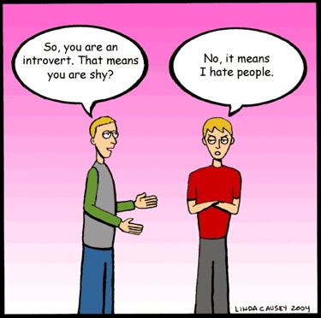
Amir, on the other hand is a person who is reserved, quiet, and private. He is more interested to be on his own and enjoys reading, writing and watching television.. He is shy and does not feel comfortable in situations where there are a lot of people, though he has one or two close friends. Amir is more into studying and likes to have a career in higher education.

Introvert | Extrovert

B. What kind of a person are you? Write a descriptive paragraph (describing yourself. (At least 10 lines) You can add interesting details about your physique, your personality, your interest, etc. (10)

Q.4 We need to be ‘formal’ with people who are older and senior or those we don’t know. Similarly, we are informal with people who are our friends or are of same age. Suppose you want to invite a senior person and a friend for dinner. This is how you should invite them:

- I would be pleased if you can come for dinner at my house tonight. (formal)
- What about coming to the dinner party? (informal)

Write formal or informal expressions of invitation in each of the following situations. (10)
i. Invite you grandfather on the annual prize distribution in your school.
ii. Invite your younger brother to go out with you for an ice cream.
iii. Invite your senior teachers to have lunch with all the class fellows.
iv. Invite your boss to come for Eid lunch.
v. Invite your friends to go with you for a music concert at your college.

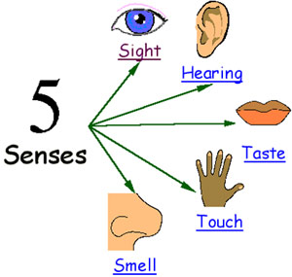
Q.5 In unit 5, you have done exercises 4 -6 which teach you about the five senses.
Our senses allow us to enjoy our food, the sound of music, the beauty of a sunny day, the softness of a child's hair -- in short, our lives! We rely on our five senses to provide information about the world around us. Here is an example:

Spring
[See] Spring brings bright green grass.
[Hear] Birds sing in the trees.
[Taste] Juicy mangoes ripen in the sun.
[Touch] The velvety touch of a rose.
[Smell] The scent of rain mixes with that of earth.
  - We call these people ‘special’ people, but they have other names too. Can you write what these people are called? (03)

i. People who cannot hear are .
ii. People who cannot speak are .
iii. People who cannot see are .

  - Write at least three things to answer the following questions: (04)

i. What kinds of things do we hear?
ii. What kinds of things do we smell?
iii. What kinds of things do we like to taste?
iv. What things are soft, rough and hard to touch? ( at least one for each)

C. Try to be creative and add lines to this poem: (03)

I have two eyes to see with
I have feet to ________
I have two hands to wash with
And nose I have but one.
I have to ears to _________ with,
And a tongue to __________.

Q.6 In unit 4 “Talking about your travelling plans”, you have learnt about what arrangements one has to make before travelling and what things to take when going on a journey. You have also read interesting descriptions of places and have also learnt to write descriptions. Write a short paragraph of not more than 8 /10 sentences about where would you like to go to and what arrangements or planning you need to do for your travel? (15)

Q.7 A. Look closely at the picture given below. There are 10 things or items in the picture. Can you write the names of these items? (10)

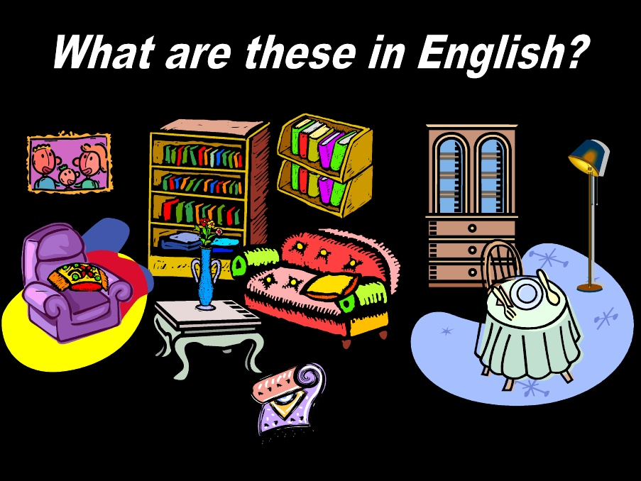
B Compose an interesting paragraph of around 100 words, describing the room given in the picture below. (15)
